BIOS and POST Troubleshooting Theory
BIOS and POST Troubleshooting Assignment
1. Five common BIOS or POST error messages and their meanings
BIOS stands for Basic Input/Output System. It is firmware that initializes the computer's hardware and helps start the operating system. POST stands for Power-On Self-Test, a series of checks performed when a computer starts.
If POST detects a problem, the PC may display an error message, produce beep codes, or stop before Windows loads.
No. | BIOS or POST error message | What it usually indicates | Possible solution
1 | CMOS Checksum Error – Defaults Loaded | The saved BIOS settings cannot be validated. A weak CMOS battery or corrupted BIOS settings may be responsible. | Load BIOS defaults, check the date and time, and replace the CMOS battery if necessary.
2 | Keyboard Error or No Keyboard Detected | The keyboard is not detected, or its connection or controller has a problem. | Reconnect the keyboard, try another USB port, or test a working keyboard.
3 | CPU Fan Error | The CPU fan may not be detected, may be disconnected, or may be running below the expected speed. | Check the CPU fan connection and confirm that the fan rotates correctly.
4 | No Bootable Device Found | The firmware cannot find a suitable boot device or operating system. | Check whether the SSD/HDD is detected and verify the boot order.
5 | Memory Error / RAM Not Detected | The system cannot detect or initialize its memory correctly. | Power off the PC, reseat the RAM, and test compatible modules individually if necessary.
These messages and their exact wording vary between motherboard manufacturers and BIOS versions. For example, HP documents CMOS checksum errors that may be associated with a weak system-board battery or an unsuccessful BIOS update.

HP® Support
Explanation
- CMOS checksum error: The firmware detects that saved settings are invalid or inconsistent.
- Keyboard error: The computer cannot properly detect or communicate with the keyboard.
- CPU fan error: The motherboard cannot detect the expected fan signal or speed.
- No bootable device: The system cannot find a usable operating system on the configured boot devices.
- RAM error: The memory may be incorrectly installed, incompatible, or faulty.
Conclusion: BIOS and POST messages help narrow down hardware or configuration problems before the operating system starts. Always confirm the message using the motherboard or computer manufacturer's documentation.
2. Three repeating beeps and no display on an AMI BIOS system
Scenario
A desktop PC is switched on. It produces three beeps in a repeating pattern, and nothing appears on the monitor.
What does the beep code typically mean?
For classic AMI BIOS, three short beeps typically indicate a main memory read/write test error, historically described as a failure in the first 64 KB of system memory. This points toward a possible RAM or motherboard memory-subsystem problem.
asrock.com
+1
However, beep-code meanings differ between older AMI BIOS versions, modern AMI UEFI implementations, and individual motherboard manufacturers. Confirm whether the pattern consists of three short beeps and consult the manual for the exact PC or motherboard model.
ASRock
+1
Two troubleshooting steps
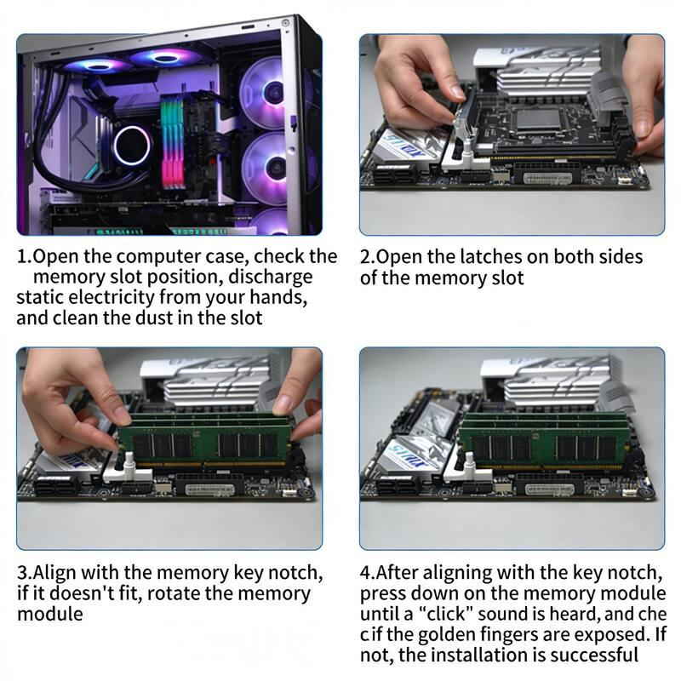
Step 1: Reseat and test the RAM
- Shut down the PC and disconnect its power cable.
- Follow anti-static precautions before touching internal components.
- Remove the RAM modules using the motherboard's release clips.
- Reinstall them firmly in the recommended slots.
- If the error continues, test one compatible RAM module at a time, following the motherboard manual.
Reason: A loose, incompatible, or faulty RAM module can prevent memory initialization.
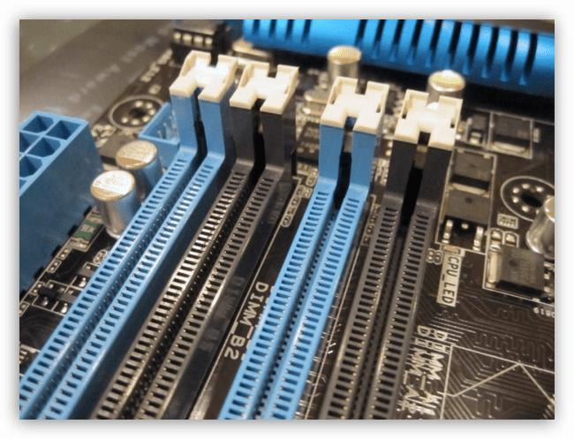
Step 2: Check the motherboard and memory compatibility
- Consult the motherboard manual for the meaning of the beep pattern.
- Check the supported RAM type, capacity, and installation slots.
- If compatible RAM modules still fail, inspect the memory slots and seek qualified testing of the motherboard and CPU memory controller.
Reason: The fault may be caused by a damaged memory slot, motherboard circuitry, or a memory-controller issue rather than the RAM module itself.
Expected result
If reseating or replacing an incompatible or faulty RAM module resolves the problem, the PC may complete POST and display the manufacturer's startup screen.
If the three-beep pattern continues, further testing is required. The beep code alone does not prove that the RAM itself is defective.
Conclusion: Three short beeps on a classic AMI BIOS commonly indicate a memory-related error. Start with safe RAM checks and then verify the motherboard-specific diagnostic code.
3. Access the BIOS setup utility and identify the motherboard manufacturer and BIOS version
Aim
To enter the BIOS/UEFI setup utility, capture a screenshot of the main screen, and identify the motherboard manufacturer and BIOS version.
Step-by-step procedure
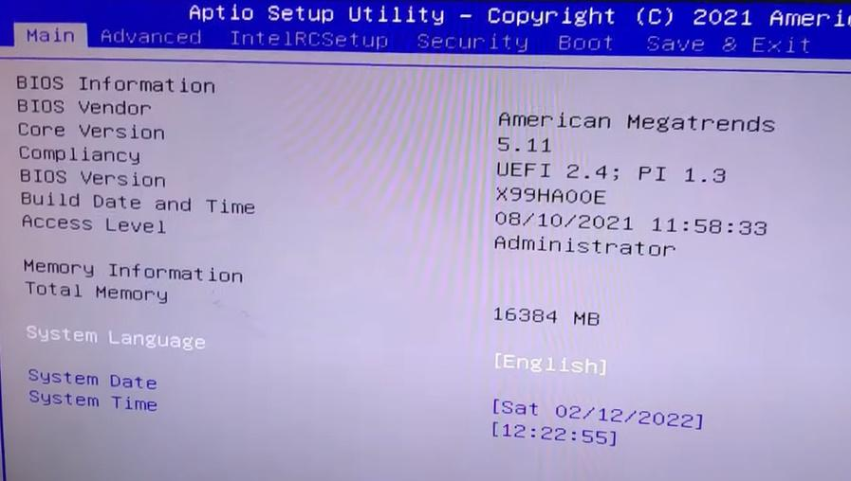
Step 1: Restart the computer
Save your work and restart your PC. As it starts, press the BIOS setup key repeatedly.
Common keys include:
- F2 — common on laptops.
- Delete — common on desktop motherboards.
- F10 or Esc — used on some systems, including certain HP computers.
The correct key depends on the manufacturer.

Tom's Hardware
+1
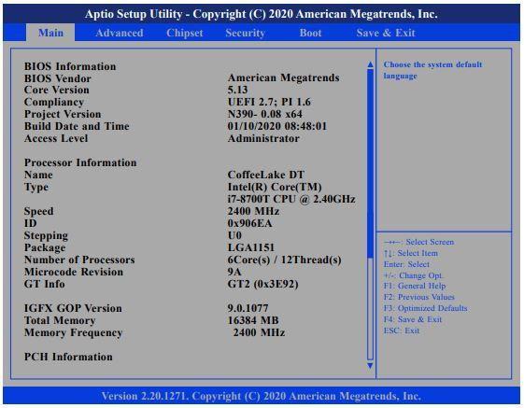
Step 2: Open the main BIOS screen
After entering setup, look for a page named Main, System Information, or Overview.
Depending on the computer, it may display the manufacturer, motherboard or system model, BIOS version, BIOS date, processor and installed RAM.
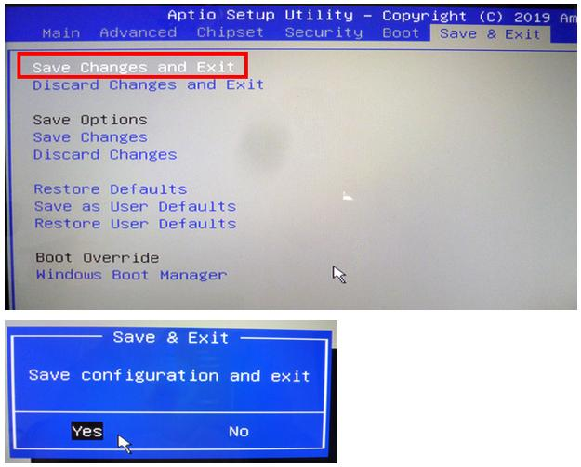
Step 3: Record the information
Write down the exact manufacturer and BIOS version shown. Do not change settings while exploring the setup utility.
Step 4: Capture the screen
If the BIOS utility does not support screenshots, take a clear photograph with a phone, or use your virtual machine's screenshot feature if working in a VM. Crop out serial numbers or other personal identifiers before submitting.
Alternative method for finding the BIOS version in Windows
If you cannot enter BIOS immediately, you can identify the firmware information through Windows:
- Press Win + R.
- Type msinfo32 and press Enter.
- Find these entries in System Information:
  - BaseBoard Manufacturer
  - BaseBoard Product
  - BIOS Version/Date
- Record the displayed values.
This alternative identifies the information but does not replace the required BIOS-screen screenshot.
Practical observation table
Fill in these details using your own computer.
Information required | Your observation
Computer manufacturer | __________________
Motherboard manufacturer | __________________
Motherboard model | __________________
BIOS manufacturer | __________________
BIOS version | __________________
BIOS date | __________________
Screenshot attached | Yes / No
Example only: A motherboard information page might show ASUSTeK Computer Inc. as the manufacturer and a firmware version such as 2806. Your actual manufacturer and version may be different.
Result: The BIOS setup utility was accessed, and the motherboard and BIOS information was recorded from the system's actual firmware screen.
Submission requirement: Attach your own BIOS screenshot. The illustrative images above are references, not screenshots captured from your computer.
4. Explain “CMOS checksum error – Defaults loaded” and describe how to resolve it
Meaning of the error
The message “CMOS checksum error – Defaults loaded” means the BIOS/UEFI firmware has detected that its saved configuration data does not pass its integrity check. As a result, it has loaded default settings to allow the computer to continue starting.
The message commonly occurs because of a weak CMOS/RTC battery, corrupted settings, or a problem following a BIOS update.
HP® Support
+1
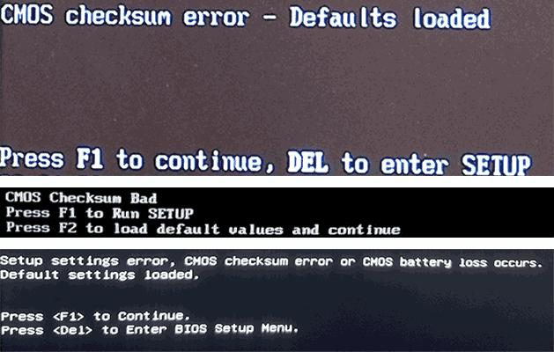
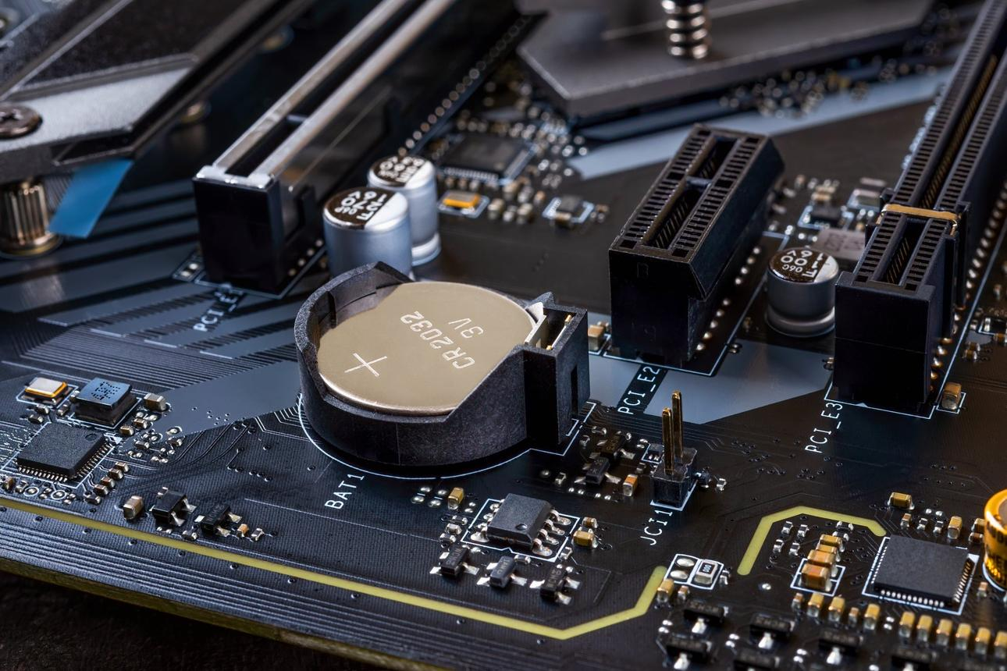
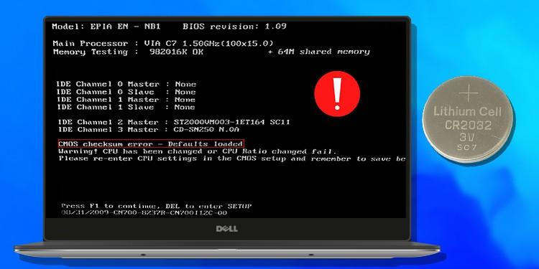
What is the CMOS battery used for?
The CMOS/RTC battery, often a CR2032 coin-cell battery in desktop PCs, helps maintain the real-time clock and certain firmware settings when the computer is disconnected from mains power.
When the battery becomes weak, the system may lose the correct date and time or repeatedly report a checksum error.
Step-by-step resolution
- Enter BIOS setup. Restart the computer and press the setup key shown by the manufacturer, such as F2, Delete, or F10.
- Load the default settings. Select an option such as Load Setup Defaults, Load Optimized Defaults, or Restore Defaults. The wording varies by manufacturer. HP also recommends restoring defaults as an initial resolution for this error.
HP® Support
- Check the date and time. Correct the system clock if it is incorrect.
- Verify boot settings. Ensure the correct SSD/HDD and boot mode are selected. Avoid changing UEFI/Legacy or Secure Boot settings unnecessarily, because this may prevent the existing operating system from booting.
- Save and restart. Choose Save Changes and Exit, then see whether the error appears again.
- Replace the CMOS battery if needed. If the error keeps returning or the clock repeatedly resets, switch off the computer, unplug it, and follow the manufacturer's service instructions for replacing the correct battery. Take precautions against static electricity and confirm the battery's polarity.
- Check for persistent firmware problems. If the error remains after the battery and settings have been checked, consult the manufacturer about BIOS recovery or service. A failed BIOS update or corrupted firmware may require further repair.
HP® Support
+1
Troubleshooting table
Observation | Likely explanation | Recommended action
Date and time reset after unplugging the PC | Weak CMOS/RTC battery | Check and replace the battery if needed.
Error disappears after loading defaults | Invalid or corrupted saved settings | Verify settings and monitor for recurrence.
Error returns after battery replacement | Incorrect installation, battery contact issue, or firmware problem | Recheck the installation and seek further diagnosis.
Error began after a failed BIOS update | Possible firmware corruption | Follow the manufacturer's BIOS recovery instructions.
Conclusion
The CMOS checksum error indicates that the saved firmware configuration could not be validated, so default settings were loaded. The first steps are to restore BIOS defaults, correct the date and time, and save the settings. If the error repeatedly returns, check or replace the CMOS/RTC battery. If the problem persists, investigate firmware corruption or other motherboard issues.
References
- ASRock — AMI BIOS beep-code meanings
- HP Support — Resolve BIOS ROM or CMOS checksum error
- MSI Support — How to access BIOS
- Dell Support — Reset BIOS/CMOS and clear NVRAM
Before submitting: Complete the BIOS observation table with your actual PC details and attach your own BIOS screenshot for Question 3.

